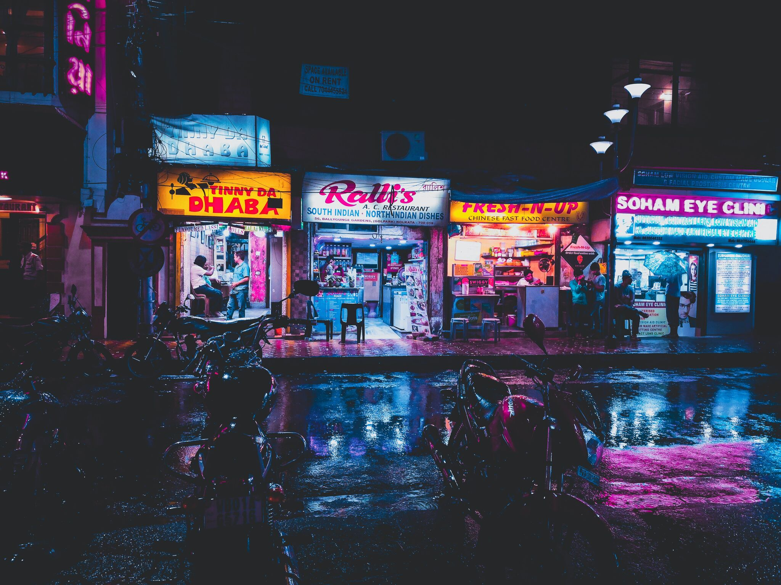
It finally happened!!

I found out how to explain what I do, on a bus, while talking to people who do not even have senior secondary education.

I was on my way back from work, standing in the last section on a BMTC bus, getting elbowed by people left right and centre, avoiding sweaty underarms, and prowling like a panther to jump on the next empty seat.

I got a seat beside 3 people my age.

All of them were on their phones, yet also had their arms over each other's shoulders.

I struck up a conversation, in my usual attempt at trying to understand their profile-

They said they worked on putting up Sb.

"What is a SB?" I asked, and they did not know how to explain it either.

"Wait" one of them said, and suddenly all of them started trying really hard to spot something on the streets

"Look there", the middle guy said pointing at a Neon Sign board.

Sign board. SB. Got it. Cool stuff.

"What do you do?"

People who work in the field, somehow inherently know what behavioural science is about.

Which I find fascinating because in my view, at best we just have approximates of what human behaviour is.

Forget that- we do not even have a proper definition of what sciences are.

In my college, we learnt a pretty straightforward definition of science.

A systematic method of discovering and organising knowledge in an evidence-based method.

Kuhn came along and said, dude, here is a little something I call "paradigms", so, how about having some existential crisis?

One needs to ask fundamentally, where does all the science come from?

We generate knowledge, we find out it works. We find uses for it. We generate more knowledge around it. Suddenly, it is a field- Which now everyone wants to claim for themselves.

Everyone wants to show a signboard they can call their work.

And I wondered If that is what behavioural science is trying to do too.

I asked myself again, How is knowledge generated?

Via curiosity, via asking questions, via questioning what makes an apple fall.

And I answered-

I ask questions for a living.

"What kind of questions?"

Well, you all are coming back from work. It is an hour-long deal. You all were using your phones, you all were within your own worlds, yes?

"yes"

Yet you still had your arms on each other's shoulders, I could see you guys are buddies, yes?

"yes"

Now Imagine there was no phone, Imagine you were in the 1950s. In this bus- do you think your friendship would get deeper? that you'd be talking to each other more?"

They paused, and their expressions changed, they were confused at first, and surprised later, and then, there was a curious gleam in their eyes.

"I get paid to then try and answer these questions"

They understood. It suddenly was not so alien to them.

I didn't use the words behaviour or science once.

I guess that'll be my signboard for now.

